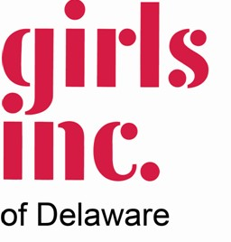
My Strong, Smart, and Bold Future
To celebrate Women's History Month and to show we Believe in Girls. Girls Inc. of Delaware (GIDE) welcomes girls, from the entire state of Delaware,
ages 6 to 18 years old to submit an essay titled My Strong, Smart, and Bold Future.
Submission requirements: handwritten or typed, share your plans for the future must include the words (My Strong, Smart, and Bold Future) and no more than 1000 words.
Submissions accepted via one of the following:
1501 North Walnut Street Suite 100 Wilmington, DE 19801 or gide@girlsincde.org .
All submission must be received by 6 p.m. March 31, 2020. Submission submitted via email must be titled: My Strong, Smart, and Bold Future include first name Questions about the process send to gide@girlsincde.org

Winners will be announced via social media and contacted on April 7, 2021. All winning submissions will be posted on GIDE’s website via a special page created just for submissions. The winning essay will remain on the page until June 30, 2021 and
highlighted in various GIDE communications

Submissions will be judged on the following:
Grades K-5:
      - Career plans and/or ideas of what enjoy and why
      - Sharing achievements received (Honor roll, Sports,etc…)
    - Use of Strong Smart & Bold
Grades 6-8
    - Considering high school and career plans
- Participates in extracurricular activities (clubs or organizations)
    - Plans or has attended tours (high school, careers & college)
- Use of Strong Smart & Bold
Grades 9-10
- Participates in extracurricular activities (clubs or organizations)
- Plans or has attended tours (high school, careers & college)
- Preparing for SAT/ACT
- Searching/Applied for Scholarship or Internship
- Chosen/Searching for Career field
- Use of Strong Smart & Bold
Grades 11-12
- Currently has an internship/volunteers or works Completed college/additional studies applications (received acceptance letters)
- Career field chosen
- Activities (Clubs & Organizations)
- Scholarship/Awards
- Use of Strong Smart & Bold

Submission will be judged by supporters from the community (no GIDE staff/board members will judge submissions).

Prizes:
A personalized award
Recognition during the GIDE Annual Meeting (May 2021) GIDE sway
Monterey prize

