What to expect:
- Interactive Games
- Reading, Science & Math Learning
- STEM, Field Trips, Art Program
- Self Esteem & Leadership Skills
And of course, FUN & Friendship Building
“Inspiring all girls to be strong, smart & bold”

GIRLS INC ENRICHMENT/STEM

Celebrate Girl Power with us! This all-day summer camp is a girls-only experience designed to meet the needs of girls ages 6-12! Girls Inc. of Delaware’s camp is dedicated to teaching girls the importance of Reading, Math & Science, Self-Reliance, Fitness, and Creative Expression & New Experiences through weekly themed activities.

When: Monday – Friday June 21st through August 6th, 2021
Where: 1501 N. Walnut Street Wilmington, DE 19801
Hours: 9:00am – 5:00pm (Drop off opens at 8:30)
Cost: $140 per week – POC Accepted Sliding Fee Scale

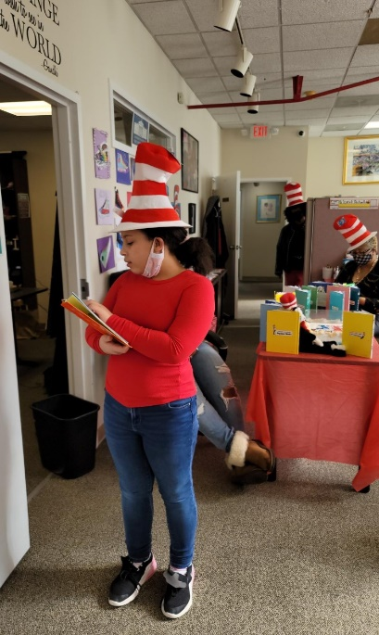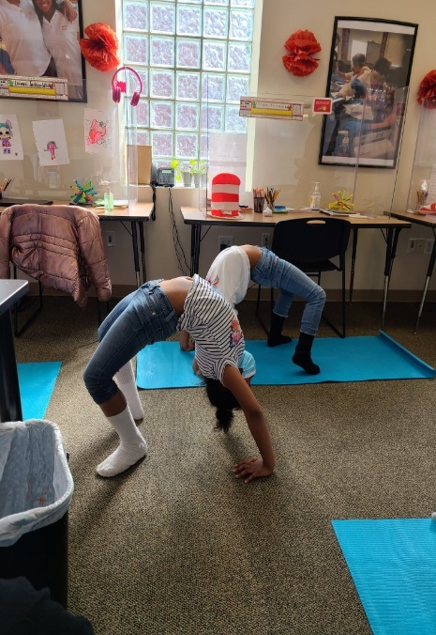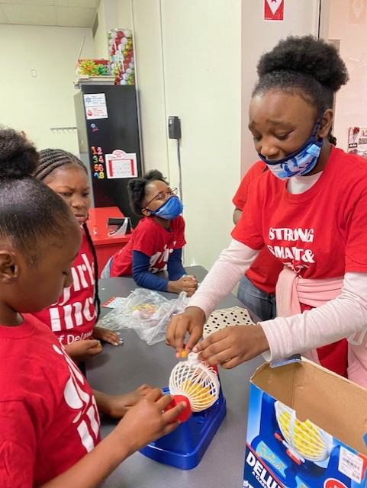

Registration Now Open Call: 302-575-1041
Registration Deadline – June 18th, 2021

