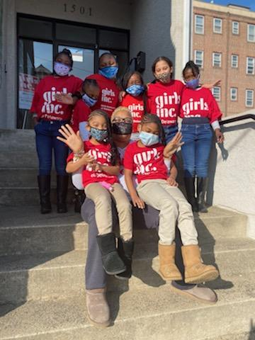

Date
Board of Directors:

Suzette M. Schultz
President

Monica M. Henry
Vice President

Renee Villano
Treasurer

Kelly A. Wellbomi
Secretary

Board Members:

Natasha M. Ortega
Patricia Ponzo
Courtney Hutt

Honorary Board

Alan Craig, Ph.D.
John Gehret, M.D.
Sideny W. Hess, Ph.D.
David Hillegas
Judy Kraut
Betty Rivers
Lynn Herrick Sharp
Mary A. Turner
Governor & Mrs. Dale Wolf

Advisory Board

Victoria Cooke
Bonnie Copeland
Lisa Davis
Senator Margaret Rose Henry
Lynn Glaze
Senator Gregory F. Lavelle
Sonia Sloan
Rita Turner

Yolanda A. Curtis, MPA
Executive Director/CEO
Name:
Address
Address

Dear Potential Board member:

Congratulations,

You have been nominated as a potential board member of Girls Inc. of Delaware (GIDE).
Girls Inc reemerged in September 2020 as a thriving vital organization after Covid shut down the operations in March 2020. With a new Executive Director and Staff, GIDE is committed to the mission of “Inspiring all girls to be Strong, Smart and Bold”.

As a potential board member to Girls Inc. of Delaware - you are one of those incredibly special people that will share your time, talent, and resources to support the mission. With the expansion of our board membership, we are excited to share with you our 2-year strategic plan that outlines the outreach efforts to create opportunities for Girls in Delaware to have the Girls’ Inc Experience.

We have decided to establish a new slate of committee members, that will continue providing board engagement, sharing of ideas and feedback from potential members.
In support, we are inviting you to volunteer to join any of our committees listed below. The term will be a 2-year length for new members.
Committee and Committee Chairs:

- Annual Luncheon
- Provide additional
Your potential board membership of Girls Inc. of Delaware facilitates that staff and volunteers deliver the Girls Inc experience to girls who parents preferred them in our programs. Girls receive mentoring and tutoring that build self-confidence which achieves academic success, self-esteem, and exposure career paths.

In support of our board engagement and feedback, we will have several committees to cultivate and foster the Girls Inc Experience for potential board members.

We would like to thank you in advance for your consideration for board membership to achieve the right fit your feedback and ideas are instrumental in strategically position the board to provide the governess for the organization.
Most importantly, thank you for considering being a champion for girls in Delaware – together we stand in their corner so that they will win in every area of thier life!

Patricia Ponzo.

Governess, Board of Director
Governess

